Nepal College of Information Technology
Unit Test
Spring 2012
Program : BE IT Time : 2 hrs
Semester : (VI) FM : 70
Subject : Engineering Math-II PM : 35

- Candidates are requested to give their answer as far as practicable in their own words.
- The figure in the margin indicates the full marks
- Attempt ALL question

1 Solve the following differential equation.
a) 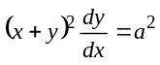 7
b) 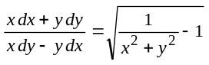 8
2. a) Define exactness of differential equation.
Solve 2xy dy = (x² + y²)dx, y(1) = 2. 8
b) Coshx dy + (y sinhx + e^{x})dx=0 7
3. a) 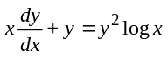 7
b) Solve 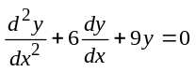 8
4. a) Solve (D⁴ +4)y=0 8
OR
y"-3y'+2y=4x+e^{x}
b) 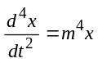 7
OR
y" +2y' +y = e^{-x}
5. Attempt all the question 2*5

a) Find the degree and order of differential equation
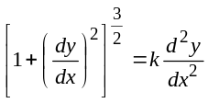
b) 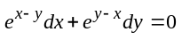
c) 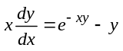
d) Solve 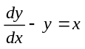 by variation of parameter method
e) y"-25y=o

